May 27, 2025
For Immediate Release
Amanda Anderson
Amanda@pablocenter.org

National Tour Press Contact: Amenkha Sembenu

WINNER! TONY AWARD – BEST MUSICAL
WINNER! NEW YORK DRAMA CRITICS CIRCLE AWARD – BEST MUSICAL
WINNER! DRAMA DESK AWARD – BEST MUSICAL
WINNER! OUTER CRITICS CIRCLE AWARD – BEST MUSICAL
WINNER! DRAMA LEAGUE AWARD – BEST MUSICAL
WINNER! GRAMMY AWARD – BEST MUSICAL THEATER ALBUM
“THE BEST MUSICAL OF THIS CENTURY.
Heaven on Broadway! A celebration of the privilege
of living inside that improbable paradise called a musical comedy.”
Ben Brantley, THE NEW YORK TIMES

NATIONAL TOUR OF

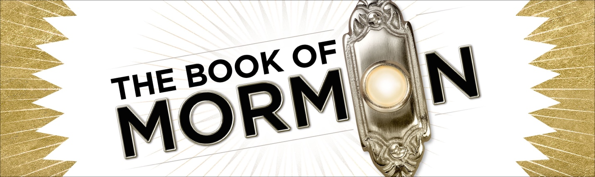

TO PLAY STRICTLY LIMITED 2 DAY ENGAGEMENT AT

PABLO CENTER IN EAU CLAIRE, WI NOVEMBER 1-2, 2025

EAU CLAIRE – The National Tour of THE BOOK OF MORMON, winner of nine Tony Awards including Best Musical, will play a strictly limited engagement from November 1 through November 2 at the Pablo Center in Eau Claire, WI. Pre-sales are available to Pablo Center members May 28-29, and on-sale to the public May 30 at 10 AM (CST). Group orders of fifteen or more may be placed by calling 715-832-2787.

THE BOOK OF MORMON features book, music and lyrics by Trey Parker, Robert Lopez and Matt Stone. The Broadway production is directed by Parker and two-time Tony Award winner Casey Nicholaw and choreographed by Nicholaw. The tour is directed and choreographed by Jennifer Werner based on the original Broadway direction and choreography. Set design is by three-time Tony Award winner Scott Pask, costume design is by Tony Award winner Ann Roth, lighting design is by five-time Tony Award winner Brian MacDevitt, sound design is by two-time Tony Award winner Brian Ronan, and hair design is by Josh Marquette. Orchestrations are by Tony Award winner Larry Hochman and two-time Tony Award winner Stephen Oremus. Music supervision and vocal arrangements are by Stephen Oremus. Casting is by Carrie Gardner.

Since opening on March 24, 2011, THE BOOK OF MORMON has become one of the most successful shows in Broadway history, breaking the Eugene O’Neill Theatre house record more than 50 times. In addition to nine Tony Awards including Best Musical and the Grammy for Best Musical Theatre Album, THE BOOK OF MORMON won five Drama Desk Awards including Best Musical, the NY Drama Critics Circle Award for Best Musical, the Drama League Award for Best Musical and four Outer Critics Circle Awards including Best Musical.

The West End production opened in February 2013, winning four Olivier Awards including Best New Musical, and breaking the record for the highest single day of sales in West End history. The first-ever UK and European tour launched in Manchester in June 2019, winning ‘Best Theatre Show’ at the Manchester Evening News City Life Awards before touring throughout the UK and Europe.

THE BOOK OF MORMON has been performed on three continents and has won over 30 international awards. The musical has smashed long-standing box office records in New York, London, Melbourne, Sydney and in cities across the U.S. and the world.

The Original Broadway Cast Recording for THE BOOK OF MORMON, winner of the 2011 Grammy Award for Best Musical Theater Album, is available on Ghostlight Records.

NETWORKS PRESENTATIONS (Producer) is an industry-leading producer of touring theatrical productions, committed to delivering quality entertainment to audiences worldwide for more than 25 years. www.networkstours.com

# # # #

For more information, visit thebookofmormontour.com

